Routledge Encyclopaedia of Modernism Entries

Dr Dorothy Price, University of Bristol, UK

Kollwitz, Käthe (1867-1945)

Käthe Kollwitz (neé Schmidt) was born in Königsberg, East Prussia in 1867, the fifth child of Karl and Katharina Schmidt. In 1884 she entered the drawing and painting school of the Association of Women Artists in Berlin and then the Women’s School of Art in Munich. In Berlin she trained under Karl Stauffer-Bern who introduced her to the work of Max Klinger. Klinger’s 1891 treatise Malerei und Zeichnung was crucial to Kollwitz’s early decision to abandon painting in favour of the graphic arts. Kollwitz married social democrat doctor Karl Kollwitz in 1891 and moved with him to his surgery in Berlin’s east-end tenement district, the inhabitants of which became a major source for Kollwitz’s art. The couple bore two sons, Peter and Hans. In 1914 Peter died in action at the Front, further politicising Kollwitz’s practice against suffering humanity during the Weimar era. Stylistically Kollwitz remained indebted to naturalism with preferred subject matter of the poorest and most vulnerable members of society, especially mothers and children, rendered with an expressionist sensitivity and symbolic resonance. With the rise of Hitler in 1933 Kollwitz was dismissed from her professorship at the Prussian Academy of Arts, labelled a ‘degenerate artist’ and her studio closed. She died in 1945, survived by her youngest son Hans.
Kollwitz’s first major graphic series The Weaver’s Revolt (1893-1897) was inspired by Gerhard Hauptmann’s eponymous play based on the historical uprising of the Silesian weavers in 1844. It arose from Klinger’s challenge to develop an epic suite of images linked by ideas, in which themes of poverty, infant mortality, populist rebellion, conflict and oppression were foregrounded. Peasant’s War (1903-1908), the next major print portfolio, consisted of seven etchings constructed into a loose narrative cycle. Kollwitz continued making graphic cycles before, during and after the First World War, alongside sculptures, prints and posters including the emotionally devastating Woman with Dead Child (1903), the poignant Memorial to Karl Liebknecht (1919) and the arresting poster Nie Wieder Krieg! (Never Again War!) (1924). The seven-image woodcut series War, (1924) is unique amongst the many modern graphic cycles produced in response to the tenth anniversary of the First World War in its complete absence of scenes of combat or material destruction. Instead, it focuses on the symbolic perspective of wives, mothers and children on the home front in a visually powerful series of universally understood themes of sacrifice and humanity. The move from lithography to woodcut also signified a move towards greater plasticity and modelling evident in her sculptures during this period, including Tower of Mothers (1937-1938) and The Parents (1932) a monument to Peter and his fallen comrades. In all of these latter works, it is the grief, loss and sacrifice of the parents who are left behind that is the focus and also the source of their universal humanitarian appeal within the contexts of modernism.
Further Reading
Kollwitz, Käthe The Diary and Letters of Käthe Kollwitz. Edited by Hans Kollwitz. Illinois: Northwestern University Press, 1989.
Prelinger, Elizabeth et al (ed.) Käthe Kollwitz New Haven and London: Yale University Press, 1992.
[505 words]
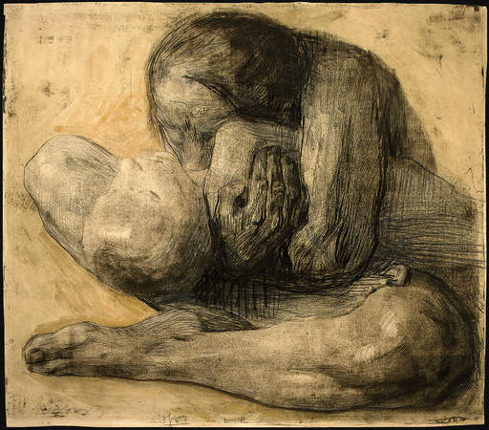
Image: Käthe Kollwitz Woman with Dead Child 1903 (Hammer Museum, Los Angeles)
(available: http://hammer.ucla.edu/image/2654/600/450.JPG)

